Docker Practical: CMD vs ENTRYPOINT
1. Create Dockerfile using CMD instruction
Create a Dockerfile to build an image named myapacheimgcmd:
FROM ubuntu
MAINTAINER Ajay
RUN apt update
RUN apt install apache2 git -y
EXPOSE 80
RUN rm -rf /var/www/html/index.html
RUN git clone https://github.com/akshu20791/apachewebsite /var/www/html
CMD ["apachectl", "-D", "FOREGROUND"]

2. Build the Docker image
docker build -t myapacheimgcmd .

3. Verify the image is created
docker images
Check that myapacheimgcmd appears in the list.

4. Modify Dockerfile to use ENTRYPOINT
Edit the Dockerfile to create another image named myapacheimgep:
FROM ubuntu
MAINTAINER Ajay
RUN apt update
RUN apt install apache2 git -y
EXPOSE 80
RUN rm -rf /var/www/html/index.html
RUN git clone https://github.com/akshu20791/apachewebsite /var/www/html
ENTRYPOINT ["apachectl", "-D", "FOREGROUND"]

5. Build the second image
docker build -t myapacheimgep .

6. Verify the second image is created
docker images
Check that myapacheimgep appears in the list.

7. Create container using CMD-based image
docker run -dt --name c01 myapacheimgcmd /bin/bash

8. Verify container is running
docker ps

9. Check Apache service status inside container
docker exec -it c01 /bin/bash
service apache2 status
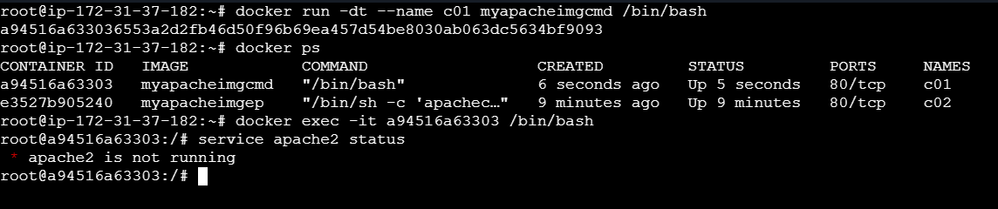
👉 You will observe that Apache is NOT running because the CMD instruction was overridden by /bin/bash.

10. Create container using ENTRYPOINT-based image
docker run -dt --name c02 myapacheimgep /bin/bash

11. Verify container is running
docker ps

12. Check Apache service status inside container
docker exec -it c02 /bin/bash
service apache2 status
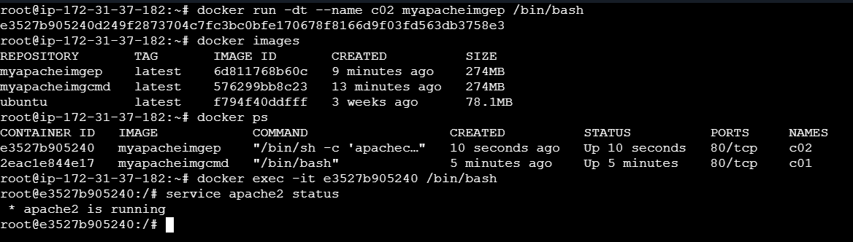
👉 You will observe that Apache IS running because ENTRYPOINT is not overridden by /bin/bash.

Difference Between CMD and ENTRYPOINT
Feature | CMD | ENTRYPOINT
Behavior | Can be overridden | Cannot be easily overridden
Flexibility | Flexible | Fixed execution
Use case | Default arguments/command | Main container process

Conclusion
- CMD provides default commands that can be replaced at runtime.
- ENTRYPOINT ensures a fixed command always runs when the container starts.
- ENTRYPOINT is preferred when you want your container to behave like an executable.

